**Final Project**

Massage Booking System

ITE 441 Database Management System

Member Group

Tinnapob Jiamjriyawat 1901070011

Kridsadee Imarom 1901240002

Fardina Kabir 1910080005

**Introduction**

We found some massage shop almost no IT involved at all the booking system for massage time uses all people, that is, customers call to reserve by phone only or come in without a reservation and have to wait in line. If the queue is busy at present, there are 3 employees and 1 shop owner and quite a lot of customers. Causing not answering the phone in time because there is no IT system. Therefore we created the database to use with application

We created this system by following the topic:

* Mini world
* Requirement
* ER-Diagram
* UML-Diagram
* A state for massage shop database
* Forward engineer
* Discussion & Conclusion

|  |  |
| --- | --- |
| **Customer** | * Customer_ID * Customer_firstName * Customer_LastName * Customer_PhoneNumber   **Add after present**   * Sex * Age * Email * Address |
| **Order** | * Customer_ID * Order_Date * CreditCard * TotalAmount * OrderStatus |
| **Order Detail** | * Order_No * Massage_Time * Price * Total |
| **Product** | * Massage_Type * Massage_ID * Massage_Time   **Add after present**   * Masseter name * Masseter no. * Masseter phone number |

**Mini world**

**Requirement**

* To reduce data redundancy
* Can be run by multiple users
* No interruptions or delays
* To work as a system based on the application
* Get more customers than ever before.
* Reduce staff work
* To make the shop look modern
* To facilitate booking

**Diagram**

**ER-Diagram**

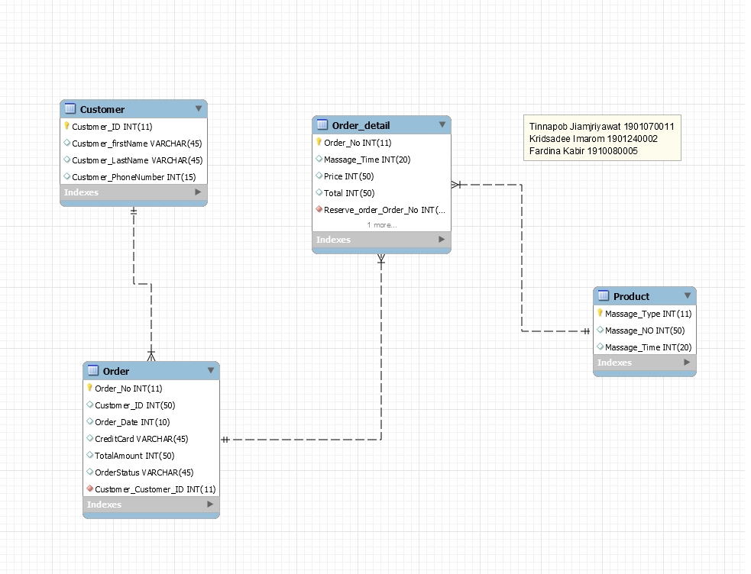

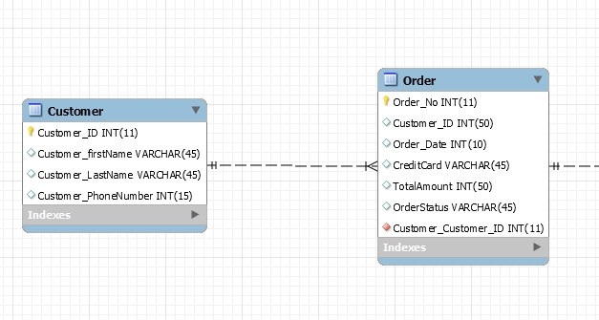

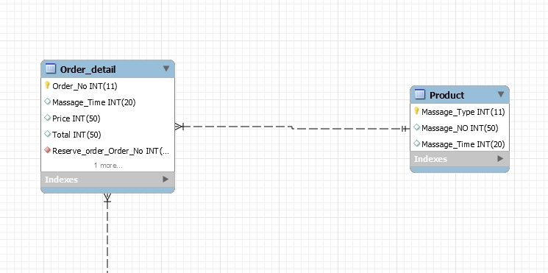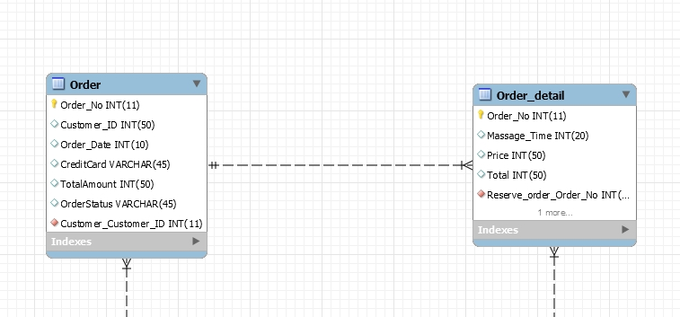

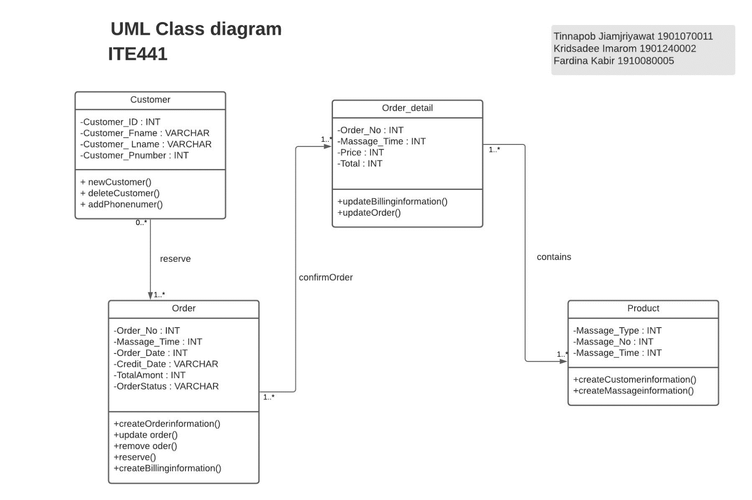**UML- Diagram**

**A state for massage shop database**

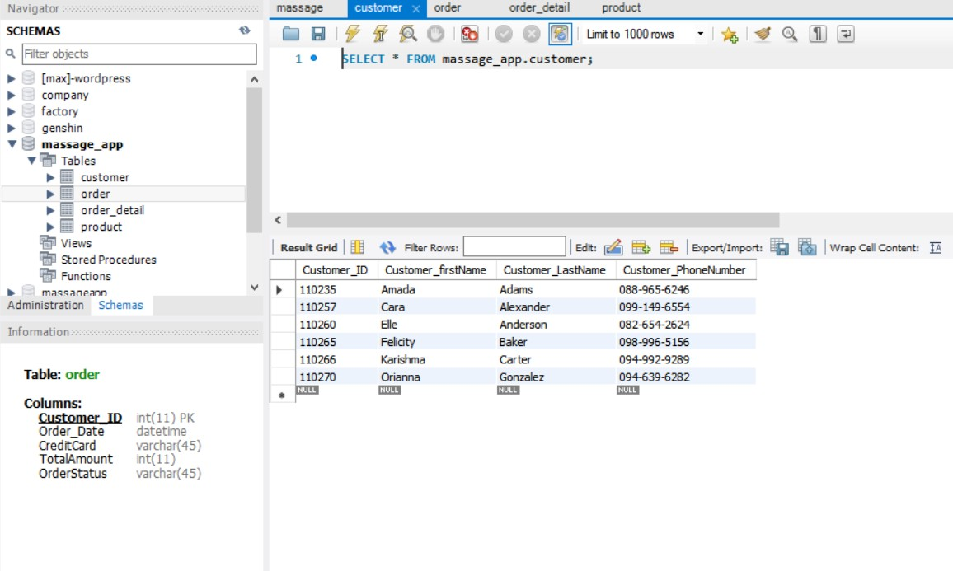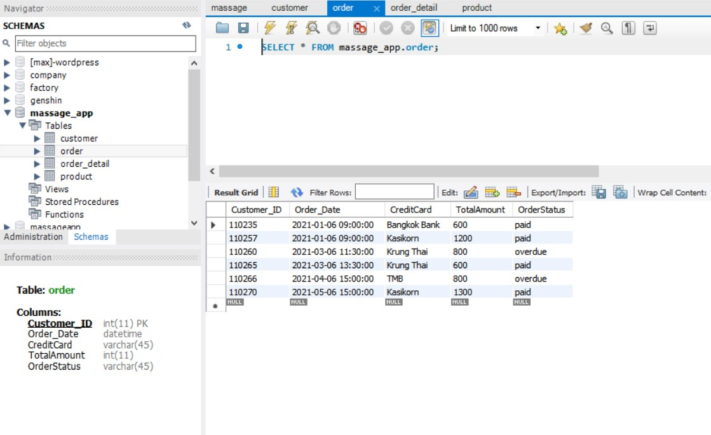

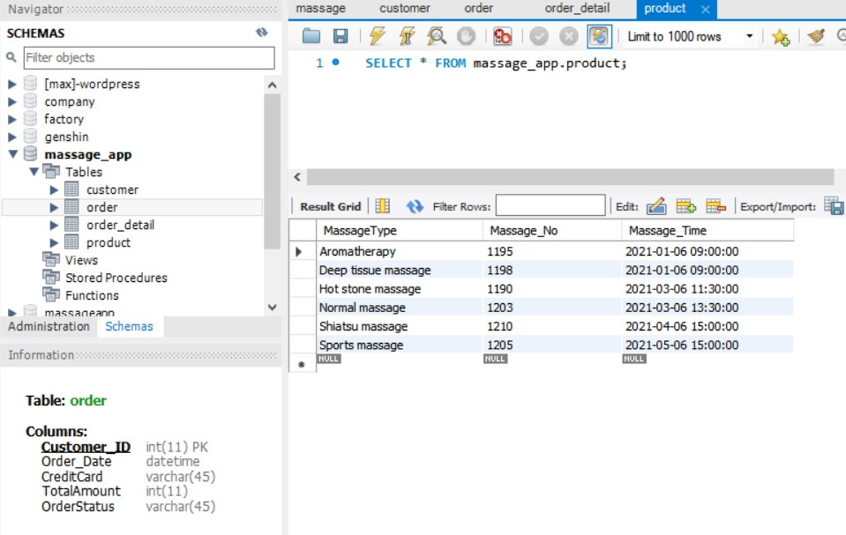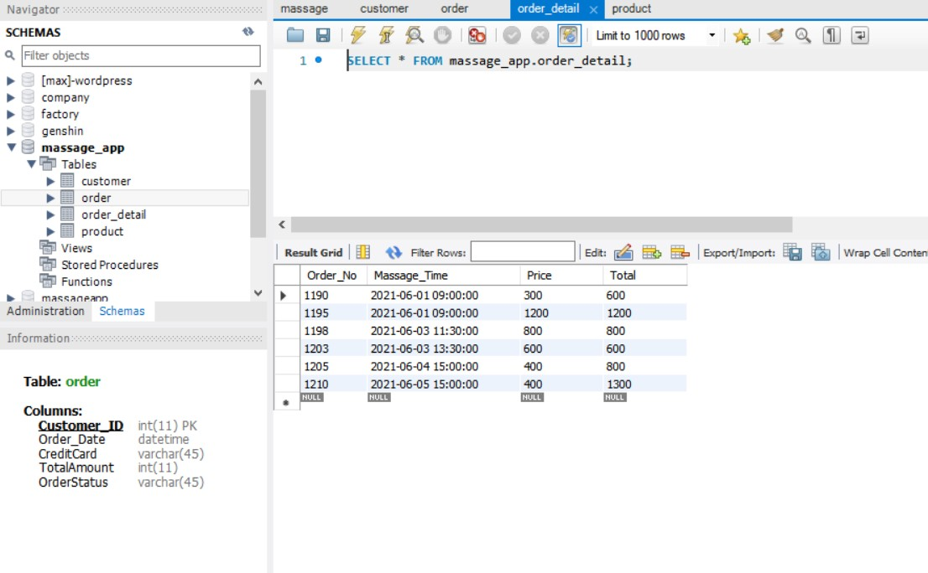

**Forward engineer**

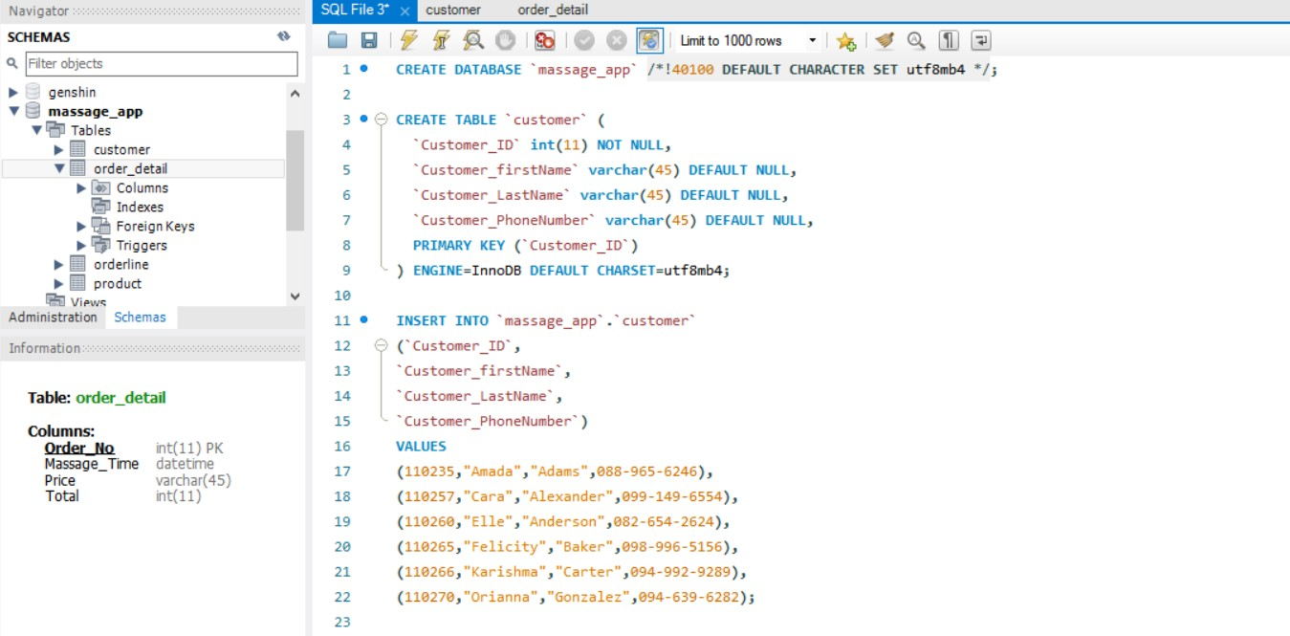

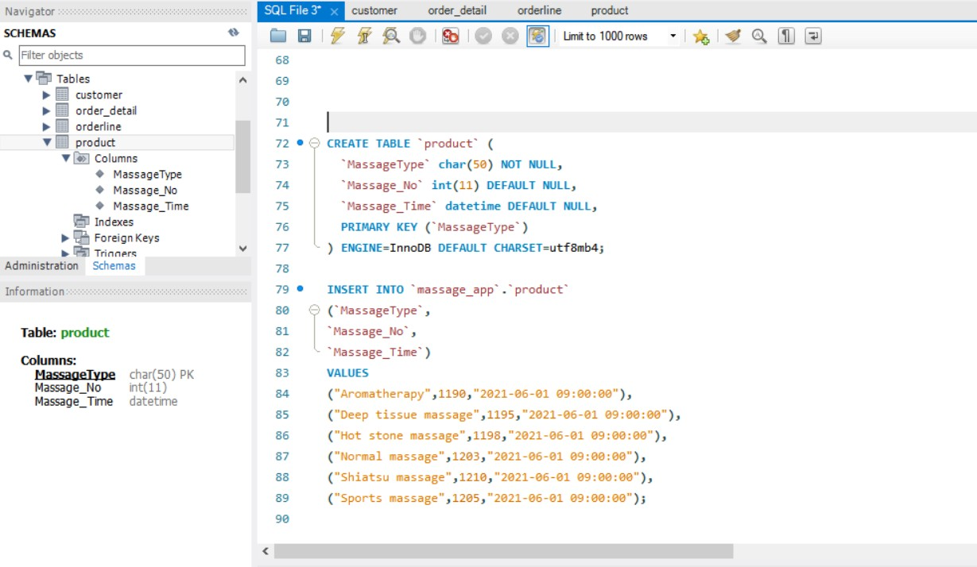

**Discussion & Conclusion**

According to the reservation system of massage parlors, the main problem is the delay in booking and there are errors

Therefore, after creating a new system, customers will be able to choose the date, time, type of massage and can choose a massage therapist. By using the online system

Massage therapists will be able to work quickly. More accurate and efficient because the system is able to notify the selected employee

In addition, customers can also receive a notification of the date and time of the reservation 1 hour before

**This is what we would like to improve**

- Add a function to collect points per 1 booking so that customers can exchange points for a massage time.

- Make a rank, starting from Silver – Diamond, the rank will increase as more customers use the booking service in the app. to make the app look playful